1. **Mocking and Stubbing**

ExternalApi.java

package com.example;

public interface ExternalApi {

String getData();

}

MyService.java

package com.example;

public class MyService {

private final ExternalApi api;

public MyService(ExternalApi api) {

this.api = api;

}

public String fetchData() {

return api.getData();

}

}

MyServiceTest.java

package com.example;

import static org.junit.jupiter.api.Assertions.*assertEquals*;

import static org.mockito.Mockito.*;

import org.junit.jupiter.api.Test;

import org.mockito.Mockito;

public class MyServiceTest {

*@Test*

public void testExternalApi() {

ExternalApi mockApi = Mockito.mock(ExternalApi.class);

when(mockApi.getData()).thenReturn("Mock Data");

MyService service = new MyService(mockApi);

String result = service.fetchData();

*assertEquals*("Mock Data", result);

}

}

**Output:**

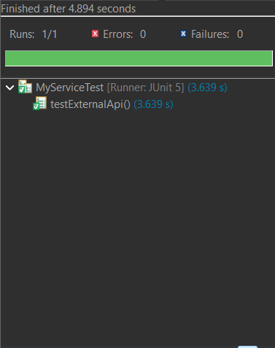

1. **Verifying Interactions**

ExternalApi.java

package com.example;

public interface ExternalApi {

String getData();

}

MyService.java

package com.example;

public class MyService {

private final ExternalApi api;

public MyService(ExternalApi api) {

this.api = api;

}

public String fetchData() {

return api.getData();

}

}

MyServiceTest.java

package com.example;

import static org.mockito.Mockito.*;

import org.junit.jupiter.api.Test;

import org.mockito.Mockito;

public class MyServiceTest {

*@Test*

public void testVerifyInteraction() {

ExternalApi mockApi = Mockito.mock(ExternalApi.class);

MyService service = new MyService(mockApi);

service.fetchData();

verify(mockApi).getData();

}

}

**Output:**

